APPENDIX D

Cost-Benefit Analysis.

|  |  |  |  |  |  |
| --- | --- | --- | --- | --- | --- |
|  |  |  |  |  |  |
|  | **0** | **1** | **2** | **3** | **4** |
|  |  |  |  |  |  |
| Development/implementation Cost | **50,670.00** |  |  |  |  |
| Operation and Maintenance Cost (10%) |  | 3,500.00 | 3,850.00 | 4,235.00 | 4,658.50 |
| Discount Factor for 14% | 1.000 | 0.877 | 0.769 | 0.675 | 0.592 |
| Time-adjusted Costs (adjusted to present value) | **50,670.00** | 3,069.50 | 2,960.65 | 2,858.63 | 2,757.83 |
| Cumulative Time-Adjusted cost over lifetime: | **50,670.00** | 53,739.50 | 56,700.15 | 59,558.78 | 62,316.61 |
|  |  |  |  |  |  |
|  |  |  |  |  |  |
| Benefits derived from operation of New System 10%) |  | 25,335.00 | 27,868.50 | 30,655.35 | 33,720.89 |
| Discount factor for 14% | 1.000 | 0.877 | 0.769 | 0.675 | 0.592 |
| Time-Adjusted Benefits | 0.00 | 22,218.80 | 21,430.88 | 20,692.36 | 19,962.76 |
| Cumulative Time-Adjusted Benefits over-lifetime: | 0.00 | 22,218.80 | 43,649.67 | 64,342.03 | 84,304.80 |
|  |  |  |  |  |  |
| Cumulative Lifetime Adjusted Cost +Benefits | -50,670.00 | -31,520.71 | -13,050.48 | 4,783.26 | 21,988.19 |
|  |  |  |  |  |  |
| ROI | 49.87% |  |  |  |  |
| NET PRESENT VALUE | 32,101.07 |  |  |  |  |
| PP | 1.20951 | 14.51409 |  |  |  |
|  |  |  |  |  |  |

ROI 49.87%

Net Presented Value 32.101.07

Payback Period 1.20

APPENDIX E

Gantt Chart.

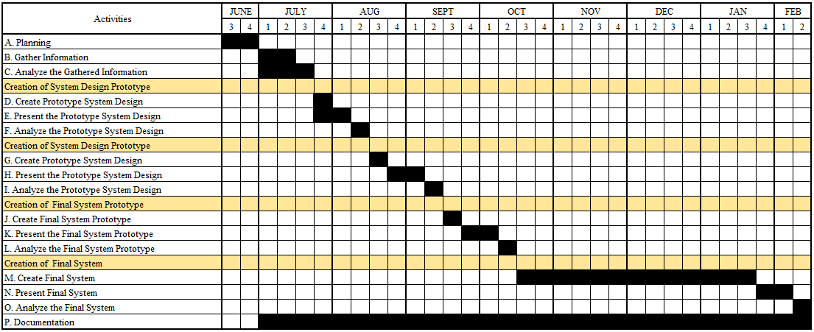



APPENDIX F

PERT Table.

|  |  |  |  |  |  |  |  |  |  |  |
| --- | --- | --- | --- | --- | --- | --- | --- | --- | --- | --- |
| Activities | Pred | a | m | b | ET | ES | EF | LS | LF | SLACK |
| A | NONE | 1 | 2 | 3 | 2 | 0 | 2 | 1 | 3 | 1 |
| B | A | 2 | 2 | 3 | 2 | 2 | 4 | 4 | 6 | 2 |
| C | A | 2 | 3 | 4 | 3 | 2 | 5 | 3 | 5 | 0 |
| D | B,C | 1 | 1 | 2 | 1 | 5 | 6 | 6 | 7 | 1 |
| E | C | 2 | 2 | 3 | 2 | 5 | 7 | 5 | 7 | 0 |
| F | D,E | 1 | 1 | 2 | 1 | 7 | 8 | 7 | 8 | 0 |
| G | F | 1 | 1 | 2 | 1 | 8 | 9 | 8 | 9 | 0 |
| H | G | 1 | 2 | 2 | 2 | 9 | 11 | 9 | 11 | 0 |
| I | H | 1 | 1 | 2 | 1 | 11 | 12 | 11 | 12 | 0 |
| J | I | 1 | 1 | 2 | 1 | 12 | 13 | 12 | 13 | 0 |
| K | J | 2 | 2 | 3 | 2 | 13 | 15 | 13 | 15 | 0 |
| L | K | 1 | 1 | 2 | 1 | 15 | 16 | 15 | 16 | 0 |
| M | L | 12 | 13 | 15 | 13 | 16 | 29 | 16 | 29 | 0 |
| N | M | 2 | 2 | 3 | 2 | 29 | 31 | 29 | 31 | 0 |
| O | N | 1 | 1 | 2 | 1 | 31 | 32 | 31 | 32 | 0 |



APPENDIX G

PERT Diagram.

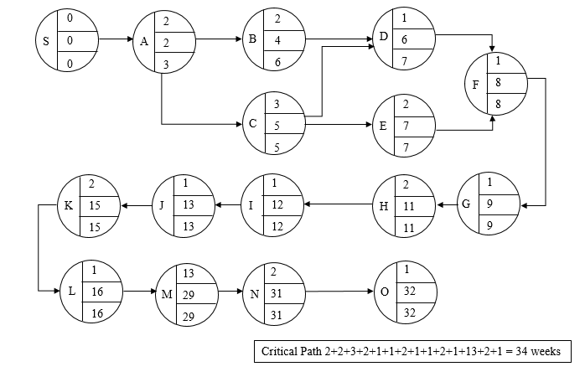

Critical Path 2 + 3 + 2 + 1 + 1 + 2 + 1 + 1 + 2 + 1 + 13 + 2 + 1 = 32 Weeks weeks